**Mary Riley Seven Mile Elementary, K-5**

**Whiteriver Unified School District 20, Arizona**

**Positive Behavior Interventions and Supports**

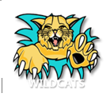

**Wildcats Do The Good**

**Seven Mile Elementary K-5**

**Positive Behavior Interventions and Supports (PBIS)**

**Handbook**

**Table of Contents**

**Table of Contents**

**Introduction to PBIS**

Overview of PBIS 2-4

Acknowledgement System 4-6

Defining and Teaching Behavioral Expectations 6

Behavioral Matrix 7-10

Kick-Off Teaching Schedule 11

Yearly Teaching Schedule 11

Calendar of morning meetings 11

Correction System – Responding to Problem Behavior 12-13

Minor Incident Referral Form 13

Classroom vs Office Behavior Management System 14

Seven Mile K-5 School Flow Chart 15

Individual Student Behavior Support 16

Check in/Check out 16-20

Appendices: Lesson Plans across Setting 21-35

* Common Areas
* Playground
* Cafeteria
* Bus Area
* Hallways
* Restroom
* Classroom

**Wildcats Do The Good**

**Seven Mile Elementary K-5**

**What is PBIS?**

Positive Behavior Interventions and Support - schoolwide approach that Seven Mile Elementary practices to increase student success and decrease disruptive behaviors.

One of the foremost advances in school-wide discipline is the emphasis on school-wide systems of support that include proactive strategies for defining, teaching, and supporting appropriate student behaviors to create positive school environments.

* Instead of using a piecemeal approach of individual behavioral management plans, a continuum of positive behavior support for all students within a school is implemented in areas including the classroom and non-classroom settings (such as hallways, buses, and restrooms).
* Attention is focused on creating and sustaining primary (school-wide), secondary (classroom), and tertiary (individual) systems of support that improve lifestyle results (personal, health, social, family, work, recreation) for all children and youth by making targeted behaviors less effective, efficient, and relevant, and desired behavior more functional.

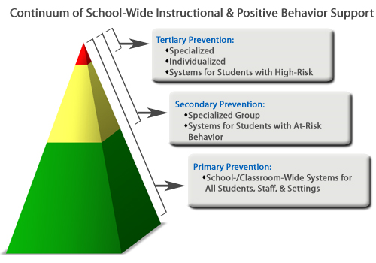

**A General Overview**

Wildcat Strong is a school-wide program based on the Positive Behavior Interventions and Supports (PBIS) framework. Staff, parents and board members have worked closely together to develop Wildcat Strong which matches the principles of PBIS in a way that fits the goals, mission and culture of the Mary V. Riley Seven Mile Elementary School (K-5)

School-wide PBIS is a research-based framework that has been proven to improve school climate, reduce problem behavior, and increase academic instructional time in schools (for additional information go to [www.swpbis.pbworks.com](http://www.pbis.org)). Two primary areas of emphasis in PBIS are prevention and instruction of social behavior. PBIS is based on the idea that when students are taught clearly defined behavioral expectations and provided with predictable responses to their behavior, both positive and corrective, all students are more likely to meet those expectations.

Through Wildcat Strong the PBIS team has developed school-wide procedures to accomplish the following:

1. **Define Behavior Expectations.** A small number of clearly defined behavioral expectations are defined in positive, simple, rules. Wildcat Strong includes making right choices, being responsible, and respectful. These expectations are defined across school settings in the Expectations Matrix included in this handbook.
2. **Teach Behavior Expectations.** The behavioral expectations and school procedures are taught to all students in the building, and are taught in real contexts. Behavioral expectations are taught using the same teaching formats applied to academic instruction. When teaching, behavioral expectations are linked to the rules of Mary V Riley Seven Mile Elementary School. The rationale for the rules and behavioral expectations are presented for each setting, then staff demonstrate examples of what the expected behavior looks like in the setting. Teachers will use videos to demonstrate the expected behavior, but may also demonstrate 1 or 2 examples of the ‘wrong way’ to do it – it is also important for students to learn what is not acceptable behavior, but there should be more focus on the desired behavior. Next, students are given the opportunity to practice the “right way” until they demonstrate fluent performance. Lesson plans for each setting are included in this handbook.
3. **Acknowledge Appropriate Behaviors** Once appropriate behaviors have been defined and taught, they need to be acknowledged on a regular basis. Giving regular positive feedback when students use behaviors they have been taught is a critical step to teaching and maintaining desired behavior. Mary V Riley Seven Mile Elementary School has developed an acknowledgment system to encourage regular recognition of desired behavior in the school. Positive or negative environments for students and staff are the result of the accumulation of individual positive or negative interactions. Research suggests that a 5:1 positive to negative ratio fosters the most positive and productive school environments. Positive interactions can occur in many meaningful ways (pat on the back, smile, verbal praise), but the goal of an acknowledgment system is to provide a regular reminder to staff during your busy day to catch kids doing the right thing. Negative interactions are defined as any time attention is given to students for problematic behavior (e.g. “Rex keep hands and feet to yourself”, “Remember class, all eyes on the teacher.”, “Sophia that’s a beautiful drawing, but it’s time to start math.”) As a school we will strive to achieve and maintain a 5:1 ratio for all students.

Through the Wildcat Strong program, “Wildcat Strong” tickets will be used by individual staff members and school volunteers to recognize students or colleagues for engaging in positive behavior. Staff members can award “Wildcat Strong” Tickets to students across all school settings, whether they teach the student or not. When handing out “WST” we should always clearly identify the specific positive behavior, the student is being recognized for and match it with one of the school rules “excellence, responsible, and respectful, safe.” The teacher places the ticket in the classroom ticket jar. School-wide drawings will occur approximately once each quarter and students drawn will receive a prize.

**Acknowledgement System**

**Wildcat Strong Tickets:**

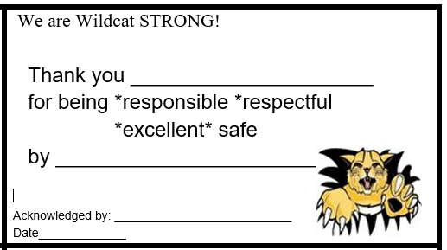

On a daily basis, a student can earn a “Wildcat Strong” ticket when they display any of the Wildcat Strongbehaviors; Respectful, Responsible, Excellent or Safe.

**Wildcat Strong Ticket (WST)**

* Individual Student
  + 1. Students earn WST ticket when displaying one of the Wildcat Strongbehaviors
    2. Teacher places the ticket into the classroom WST ticket jar
    3. At the end of the quarter, please put your tickets into the office jar.
    4. Quarterly announcements will include drawings for each grade-level from the classroom WST Ticket Jars
    5. If a student asks for a ticket then they do not receive one
    6. Train staff on giving tickets-
  + Specifically tell the student which behavior (Wildcat Strong) they displayed.
  + Be genuine, a direct interaction between staff and student
  + specific verbal praise (“**THANK YOU, GEORGE FOR BEING RESPECTFUL WHEN YOU...”)**

1. Staff Recognition
2. Leadership team members can recognize other staff members by giving them a Staff WST ticket.
3. Staff members place their ticket into a staff WST Ticket Jar
4. The principal will draw tickets from the Staff WST Ticket Jar
5. Monthly Site PD, Friday PD’s Staff will choose a prize from the staff prize box
6. Staff must be present to win

***The PBIS store***

has incentives for positive behavior. Teachers will be giving stickers for the good behaviors that they see.

1. One wildcat cash is equivalent to 4 stickers inside the classroom and inside ancillary.
2. One Sticker can be given in the morning and one in the afternoon.
3. 2 days of good behavior will equal one dollar.
4. If a student has a bad morning they can still get a sticker in the afternoon if their behavior improves or they can have a good morning and then a bad afternoon. They will still get one sticker for the day.

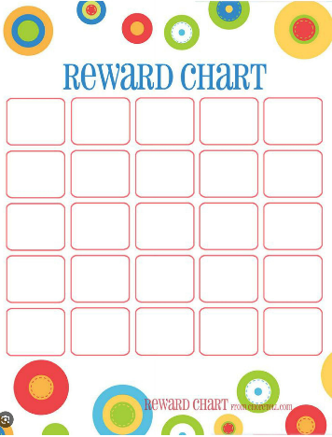**Reward chart:**

**Wildcat Cash:**

PLEASE DO NOT STAPLE OR WRITE THEIR NAME ON THE CASH. Use a paperclip and a post-it.

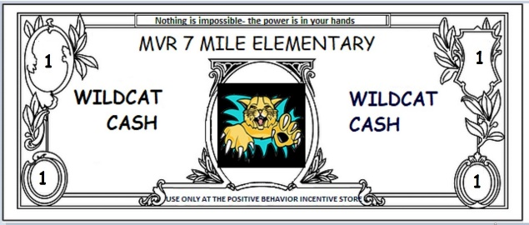

The store will open at the beginning of each quarter (2nd, 3rd, & 4th) then at the end of April-beginning of May for the last part of the year. Classes will sign up for a time to come and spend the Wildcat Cash.

**Brownie points:**

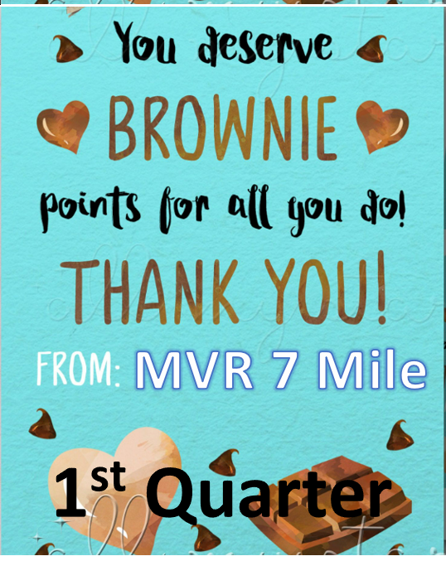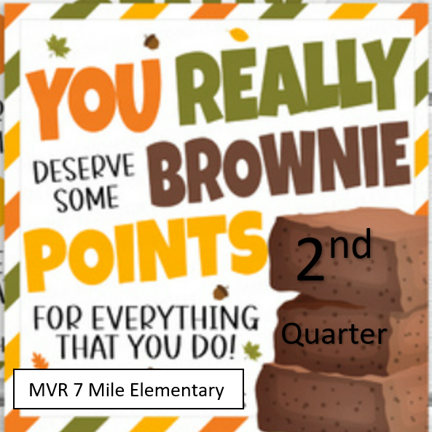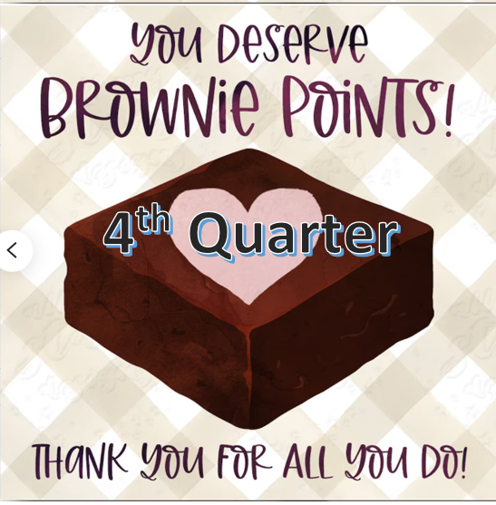

Each quarter your class will earn brownie points for perfect attendance days- The student data coordinator will put these in your mailbox at the end of the day when your class has perfect attendance.

At the end of the quarter:

1. Please send your total of points to the office
2. We will announce one class from

* kindergarten to 2nd grade
* 3rd to 5th grade

1. A classroom party will be held, choices will be discussed at a further time

**Defining and Teaching Behavioral Expectations**

Students respond to clear, consistent expectations and predictable adult responses to behavior. In order to establish a positive, predictable school environment it is important to clearly define behavioral expectations, establish agreement across staff, and actively teach those expectations from the beginning of the year to all students in the school. All staff should participate in the instruction of behavioral expectations during the first few weeks of school and throughout the school year to create a consistent, united front. The Wildcat Strong Matrix is used to identify important behavioral expectations across school settings.

The Wildcat Strong Matrix is used to guide lesson planning and teaching of prioritized behavioral expectations across settings. In PBIS, instruction of social

behavior is viewed in much the same way as academic instruction. The same principles of effective academic instruction apply for teaching social behavior. In the same way that we shouldn’t punish kids if they can’t do math problems, we should not punish students for not knowing the behavioral expectations or routines… instead we must teach them. It is our responsibility to prepare our Wildcat Strong to be successful socially by teaching behavioral expectations and school routines from the beginning of the school year, followed by periodic review throughout the year. We also understand that effective instruction of social behavior should:

1. Occur in the natural setting, for example we should teach expectations and routines for recess behavior on the playground, not in the classroom.
2. Focus on what to do instead of what not to do, for example teach how to keep hands and feet to self, instead of what not to do.
3. Physically demonstrate or model the expected behavior, not simply talk about it.
4. Give students the opportunity to actively practice the expected behavior in the real setting with feedback.
5. Link expected behavior to the School-wide rules.

**Behavior Matrix**

Behavioral Expectations and Routines for Mary V Riley Seven Mile Elementary School, K - 5

The rationale for the Matrix is to provide an example of what the expected behavior looks like for each setting.

|  |  |  |  |  |
| --- | --- | --- | --- | --- |
| **LOCATION** | **Excellence** | **Respectful** | **Responsible** | **Safe** |
| **HALLWAYS**  **COMMON AREAS**  **INSIDE BUILDING** | ● Walk facing forward  ● Keep hands, feet and objects  to self  ● Get adult help for accidents | * Use positive words & actions   ● Use appropriate voice level  ● Listen and follow directions  ● Stay in line | * Use a hall pass   ● Follow school rules  ● Take care of belongings  and equipment | * Slow speed * Stop along the way |

|  |  |  |  |  |
| --- | --- | --- | --- | --- |
| **LOCATION** | **Excellence** | **Respectful** | **Responsible** | **Safe** |
| **CAFETERIA / LUNCH** | * Walk calmly and quietly   ● Keep hands, feet and objects  to self  ● Sit on seat with feet on the  floor  ● Report spills to lunch monitor  immediately | ● Use quiet voices  ● Wait in line for your turn  ● Take only what you will eat  ●Stay seated   * Carry your tray with both hands | ●Be ready to make your  choice  ● Raise your hand to be  excused  ● Pick up all your trash  before you leave | * Wait until your table row is excused * walk with your line to the door and go to the playground with walking feet. |

|  |  |  |  |  |
| --- | --- | --- | --- | --- |
| **LOCATION** | **Excellence** | **Respectful** | **Responsible** | **Safe** |
| **RESTROOMS** | ●Keep hands, feet and to objects to  yourself  ● Wash hands  Shake excess water from your hands over the sink before getting paper towels  ● Keep floor clean and dry | Respect privacy  ● Use quiet voices  ● Wait for your turn | Flush toilet after use  ● Return to classroom quickly  ● Use a bathroom pass for emergencies  ● Throw trash away  Pick up any trash on the floor and throw away | Always walk  Return to class directly |

|  |  |  |  |  |
| --- | --- | --- | --- | --- |
| **LOCATION** | **Excellence** | **Respectful** | **Responsible** | **Safe** |
| **BUS AREA**  **TRANSPORTATION** |  | ● Wait your turn to exit  ● Use quiet voices  ● Use respectful language | ● Face forward while bus  is in motion  ● Keep hands and feet to  self  ● Take all belongings  with you when exiting | ● Stay in seat until the  bus stops.  ● Step away from bus door as others exit  ● Stay clear of curb |

|  |  |  |  |  |
| --- | --- | --- | --- | --- |
| **LOCATION** | **Excellence** | **Respectful** | **Responsible** | **Safe** |
| **PLAYGROUND / RECESS** | ● Keep hands, feet and  objects to self  ● Play approved games only  ● Walk to and from recess  ● Share and use equipment  properly | ● Include everyone  ● Use problem-solving skills  ● Help others  ● Follow game rules | ● Line up quickly with signal  ● Report problems to an adult  ● Follow adult directions | * Leave rocks and sticks on the ground * Touch football does not include pushing and tackling * Stay in designated areas |

|  |  |  |  |  |  |  |  |  |  |
| --- | --- | --- | --- | --- | --- | --- | --- | --- | --- |
| **LOCATION** | | **Excellence** | | **Respectful** | | **Responsible** | | **Safe** | |
| Classroom Behavioral Expectations & Routines | | * Make smart choices * Keep your Dear Teacher Happy | | * Raise your hand for permission to speak. * Raise your hand for permission to leave your seat. | | * Follow directions quickly * Have materials/ supplies ready to begin work. | |  | |
| **Entering the**  **Classroom:**   * enter the room quietly * use a conversational or ‘inside voice’ * keep hands, feet, objects to self * walk * move directly to desk or assigned area * sit quietly & be ready for class to begin  **Starting**  **the Day:**   * put personal belongings in designated areas * turn in homework * put instructional materials in desks * sharpen pencils & gather necessary material for class * be seated & ready to start class   **Attention**  **Signal:**   * Eyes on me- Eyes on you * Class, Class- yes, yes   **Working Independently:**   * select area to work * have materials ready * work without talking * raise hand to ask for help * keep working or wait quietly for assistance when the teacher is helping someone else * move quietly around the room when necessary * put materials away when finished * begin next activity when finished   **Working in Groups:**   * stay on task * use quiet voices * follow assigned roles * be respectful to group members * contribute to assignment.   **Asking for**  **Help:**   * raise your hand (for permission to speak). * always try by yourself first * use the classroom signal for getting assistance * keep working if you can or wait quietly * remember the teacher has other students that may also need help   **Taking care of personal needs:**   * follow the class signal for letting the teacher know you have a private concern * let the teacher know if you need immediate help or if you can wait a while * try to speak to the teacher privately & quietly if you do not want other students involved   **Transition Procedures/ Lining up:**   * wait for teacher to dismiss * line up quietly and respectfully to each other, the classroom and the teacher.   **Hall Pass**  **System:**   * sign out/ in * bring a Hall Pass with you.   **Completing & Returning Homework:**  Follow teacher’s expectations and routines for completing and returning homework, ie:   * collect your work to take home * complete work, get parent signature when needed * bring work back to school   return work to homework basket | | | | | | | |

**Mary V Riley Seven Mile Elementary**

**Kick-Off Teaching Schedule**

**Week 1 of School**

**School wide Welcome Back and PBIS kickoff**

**Plan and schedule your visits to each area with other teachers on each scheduled day to avoid crowding in certain areas. Teach the students your expectations in all areas.**

**M.R. Seven Mile Elementary**

**Yearly Teaching Schedule**

Re-teaching of behavioral expectations and routines will occur as necessary throughout the year. This will be planned by the School Wildcat Strong team and the calendar of morning meetings.

Strategic re-teaching and booster sessions will occur during the first week of school following:

* Fall Break
* Winter Break
* Spring Break

Wildcat Strong activities may be held at least each quarter to review rules and celebrate positive behavior in the school.

Schedule of morning meetings and power point should be followed, please find time to teach these lessons so

that behavior is manageable.

***CALENDAR OF MORNING MEETING***

Quarter 1 Week 1 PBIS expectations- store- $- tickets

Quarter 1 Week 2 PBIS- classroom

Quarter 1 Week 3 PBIS- hallways

Quarter 1 Week 4 PBIS- restrooms

Quarter 1 Week 5 PBIS- playgrounds

Quarter 1 Week 6 PBIS- cafeteria

Quarter 1 Week 7 PBIS- bus

Quarter 1 Week 8 PBIS- Schoolwide

Quarter 1 Week 9 Safe

Quarter 2 Week 1 REBOOSTER

Quarter 2 Week 2 citizenship

Quarter 2 Week 3 citizenship

Quarter 2 Week 4 citizenship/ veterans

Quarter 2 Week 5 thankfulness

Quarter 2 Week 6 Bullying

Quarter 2 Week 7 Bullying

Quarter 2 Week 8 bucket filling

Quarter 2 Week 9 bucket filling

Quarter 3 Week 1 REBOOSTER

Quarter 3 Week 2 kindness

Quarter 3 Week 3 responsible

Quarter 3 Week 4 responsible

Quarter 3 Week 5 responsible

Quarter 3 Week 6 caring

Quarter 3 Week 7 bucket filling

Quarter 3 Week 8 excellent

Quarter 3 Week 9 excellent

Quarter 4 Week 1 REBOOSTER

Quarter 4 Week 2 caring

Quarter 4 Week 3 Caring

Quarter 4 Week 4 fairness

Quarter 4 Week 5 fairness

Quarter 4 Week 6 Trustworthiness

Quarter 4 Week 7 respect

Quarter 4 Week 8 Excellent

Quarter 4 Week 9 Safe

Quarter 4 Week 10 celebration

**Correction System – Responding to Problem Behavior**

Despite our efforts to proactively set students up for behavioral success and to prevent problem behavior, there will still be incidences of problem behavior. When it comes to responding to problem behavior we have three primary goals:

1. Make sure to keep everyone safe.
2. Minimize the loss of instructional time for all students (including the student who engaged in the problem behavior).
3. To teach the student the appropriate behavior to use instead of the problem behavior.

Every occurrence of a problem behavior is an important opportunity to teach the appropriate, desired behavior to the student. In developing Wildcat Strong it is our responsibility to provide fair and consistent consequences for problem behavior that focus first on teaching our students the appropriate behavior and re-engages students in academic instruction quickly and as safely as possible. The Wildcat Strong team has developed a progressive discipline model that will be utilized in the school that focuses on teaching and preventing future occurrences of behavior. When students violate the behavioral expectations, they will be informed that their behavior was not acceptable and how it relates to the school wide rules of Be Respectful, Be Excellent, Be Responsible, and Be Safe Instructions on using a “Minor Incident Report” are included in this Handbook. For students who engage in recurring problem behavior, who are not responding to the school’s progressive discipline system, additional individual behavioral support will be provided.

We only earn the right to use consequences for problem behavior after explicitly teaching and reinforcing the behavior we expect. Despite our best attempts to set students up for success in a positive environment that prevents problem behavior, kids will still occasionally engage in problem behavior – they are kids! When responding to problem behavior at Mary V. Riley Seven Mile Elementary, we will be guided by the following principles:

* We will respond to problem behavior only in ways that maintain the safety, well-being and dignity of the child.
* A primary focus of responses for problem behavior is the instruction of the expected behavior
* Our primary goal in responding to problem behavior is to minimize the loss of instructional time for that student and all other students in the setting

Primary goals in responding to problem behavior are to identify minor problem behavior early and quickly and calmly redirect the student back to the task at hand. If the student does not respond to initial redirects pre-planned consequences may be required.

**Level 1 Warning:**

Staff are encouraged to deal with minor problem behavior in the classroom. The response to many behaviors will be a simple redirection and return to instruction or parent phone call home. (e.g. redirect to task, a calm response to engage in the expected behavior, or recognizing a neighboring peer for the expected behavior).

**Level 2 Minor Incident Referral:**

For student behavior that persists beyond a warning or repeated redirection, disrupts instruction, or recurring student behavior with teacher redirection should be documented in synergy under **Minor**. Staff members should clearly identify the behavior of concern, link it to violation of a school-wide rule and use the opportunity to have the student practice the appropriate response whenever possible. Staff may pair with a classroom consequence and parent contact, however, make sure to try to reduce the loss of instructional time. The Seven Mile Elementary discipline form should be used by staff members who do not have access to synergy and should be given to the teacher and when needed the office.

**Level 3:**

Serious student offenses for which the school principal will be involved call for an Office Discipline Referral in synergy. Such offenses will merit parent communication and will likely result in some disciplinary action. Disciplinary responses for Level 3 offenses will focus on minimizing the loss of instructional time and focus on returning the student to the classroom as quickly as possible when it is safe to do so. Once again, instruction of the expected behavior, including student practice, should be a consistent component of all disciplinary responses. **These referrals always are documented into synergy.**

As much as possible, natural consequences for behavior will be issued (e.g. writing an apology, making up missed instructional time), which may include restitution for damaged property.

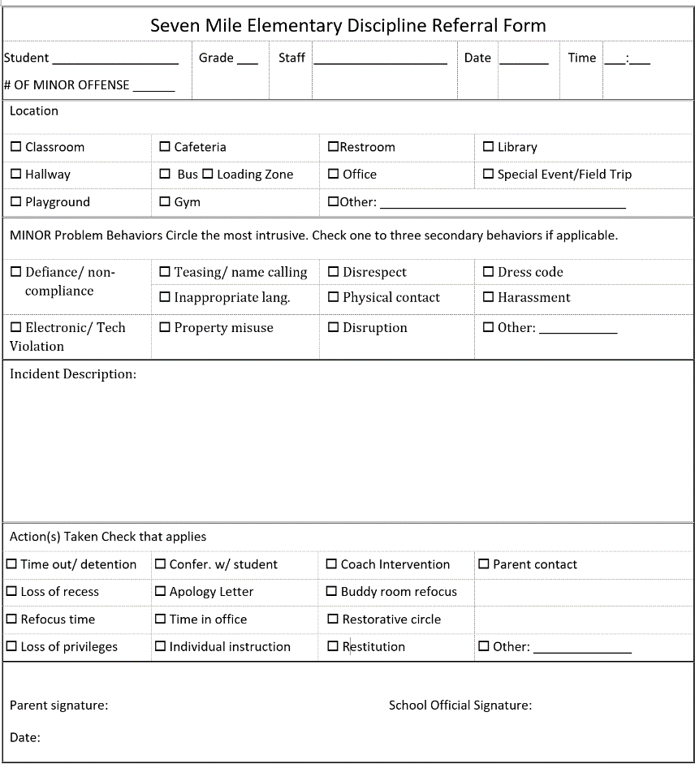

##### Classroom vs.

##### Office Behavior Management System

|  |  |  |  |
| --- | --- | --- | --- |
|  | **Level** | | |
|  | **Staff Managed** | **Office Managed** | **Office & Community** |
| **Behavior Type** | **– Minor** | **- Major**  **Office Discipline Referral (ODR)** | **- Illegal** |
| **Definition** | Problem behavior with low intensity, short duration, & does not occur with regular frequency. *Staff responds by redirect & re-teaching appropriate behavior* | A problem behavior that has high intensity, **or** long in duration, **or** occurs with increasing frequency. Staff member are **not** able to respond to independently | Behaviors that are defined by the law to be illegal. |
| **Examples** | Defiance, talk outs, running in the hallway, inappropriate language | Fighting or behaviors with the potential to harm  Sustained defiance and disruption | Drugs / possession or distribution |
| **Procedure** | 1. Remind student of rule; redirect behavior 2. Student Restates/ practices rule 3. Praise for following direction | 1. Fill out ODR form 2. Get admin. support 3. Admin. implements consequence | 1. Ensure safety of students and staff then follow procedure of major behaviors |

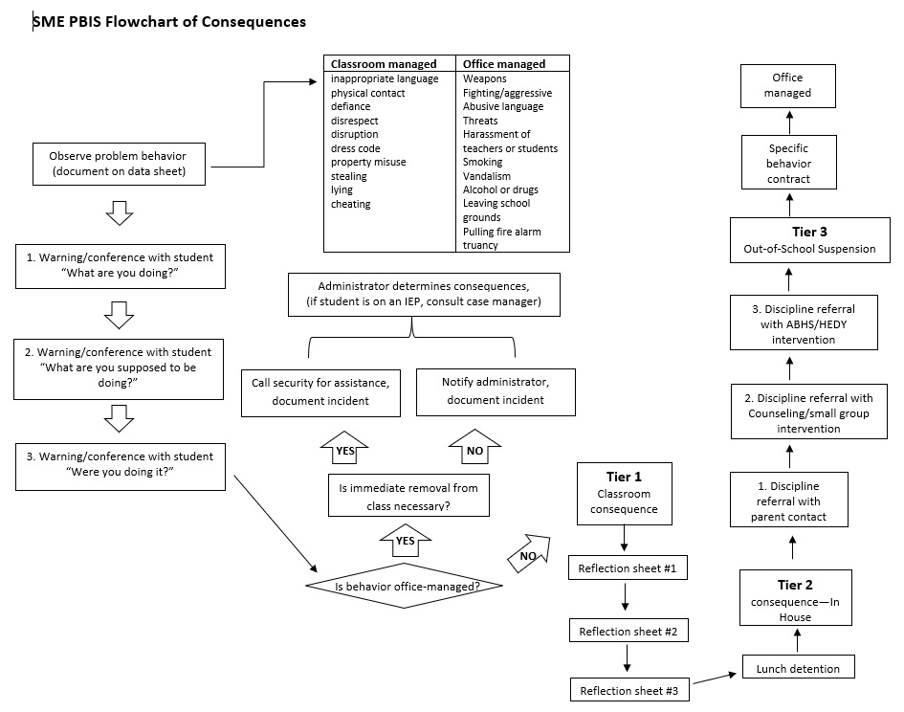

**Individual Student Behavior Support**

Wildcat Strong Team will regularly review discipline referral data to identify areas for intervention and students who are at-risk. For students who engage in repeated, chronic behavior, additional supports will be put into place. Research has found that 10-15% of students will require additional support to be successful socially in school. Some of these students will respond to simple levels of intervention, while others will require more intensive individualized support.

Wildcat Strongwill provide a continuum of individual positive behavioral interventions and supports which will be available to all students, but will be put in place to support students with recurring challenging behavior. This continuum of support will be provided for at-risk students which may include research-based interventions including Check-In/Check-Out, First Steps to Success or more individualized Positive Behavior Support Plans (BSP) based on Functional Behavioral Assessment (FBA) as appropriate. When students are identified as at-risk for problem behavior, a continuum of individual behavioral support will be provided to support students in hope of reducing their likelihood of receiving additional disciplinary contacts, suspensions and lost instructional time. Daily data will be collected for all interventions implemented with students at-risk for behavioral concerns to monitor student progress and evaluate the effectiveness of interventions.

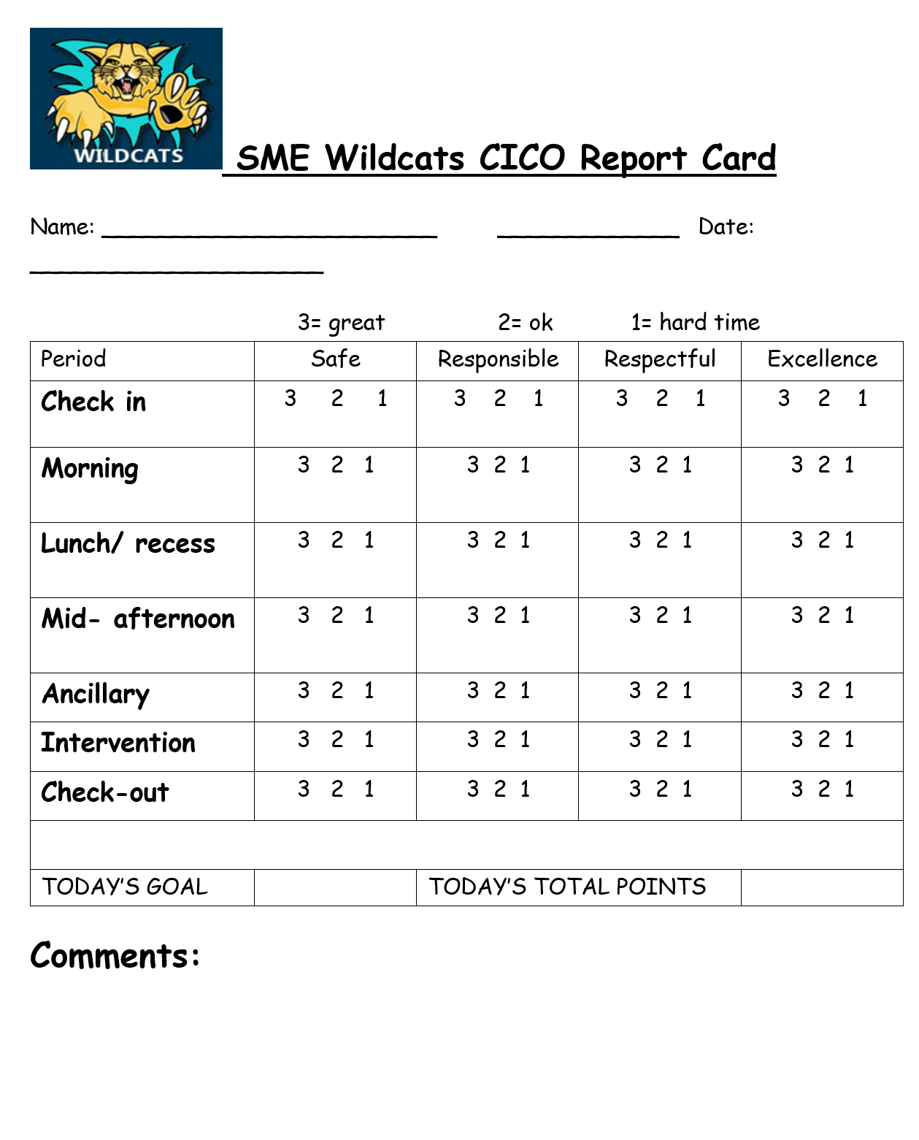

**“Tweaks” or small interventions to individualize CICO for Borderline Responders**

Occasionally a student will not respond to the intervention without some personalization. The leadership team might try the following modifications before moving to more intensive intervention.

● Change the Check-in and Check-out mentor

● Change incentive

● Change goal level, temporarily reduce percentage

● Individualize Wildcat Strong goals

● Add a mid-day Check-In with mentor and/or add incentive

● Increase frequency feedback goal sheet.

● Add a ‘Bonus Period’

● Reduce Time

Change the Check-in and/or Check-out Mentor

If a student doesn’t seem to be connecting with their Wildcat Strong mentor, here are a couple of options to consider:

a) It might help to provide relationship building/bonding opportunities for the student and their mentor by planning activities for them to do together to build that initial connection or

b) Potentially identifying a new mentor for the student. It might be helpful to ask the student for a preferred mentor or the leadership team could seek out a staff member who has a connection with the student and would be willing to be a Check-in/Check-out mentor for the student.

Change the Incentive

If the student is not interested in or responding to the standard SME Wildcats Club incentives, it may be helpful to change the incentives. It may be helpful to have a list of potential incentives and ask the student about preferences.

Change Goal Level

If a student is narrowly missing their goal 60-79% range, a temporary recommended reduction of the goal to 70% (we do not suggest reducing the goal below that, if necessary change the goals to be more achievable instead). The temporary reduction may help the student access the reinforcer and experience success and confidence which may provide motivation.

Be sure to inform the student that the reduction in the daily goal is temporary. Once the student has successfully achieved the 70% goal for a week, consider raising the goal to 75% and continue this process until returning to 80% level.

Individualize the SME Wildcats Tracker Card goals:

Another option if the student is not responding to the intervention may be to individualize their daily goals. These goals should still be linked to the school-wide expectations but should be more focused and specific to the student’s behaviors of concern. By making goals more specific, students should be able to have a clearer focus on the desired behavior which should help to make the goals more achievable for the student. Goals will be written directly next to the school expectations on individual SME Wildcats Tracker Card points.

**Once the student is experiencing consistent success with the more individualized goals, fading back to the more generic school-wide goals is encouraged.**

Add a mid-day Check-In and/or incentive

There are some students for whom waiting for the entire day to receive an incentive may be too long. Building a positive adult contact into the middle of the day may also be helpful for providing encouragement and support. A specific goal may be set with an additional incentive for a mid-day check-in.

Increase frequency of feedback”

Some students may require more regular feedback within class periods such as PE, Music, Computer Lab, or Library. Teachers and staff should seat the student in a location that is quickly accessible for providing regular feedback. Feedback can be provided periodically to the appropriate faces as feedback to the students’ behavior – it remains important to regularly recognize positive behavior. At the end of the period the face with the most hair can be circled as the overall score. This increases the amount of positive affirmation within a set of time. Forty-five minutes segments may be too long.

Add a ‘Bonus Period’

If a student is having a more difficult time during one ‘period’ on the point card – it may be helpful to highlight that period with an opportunity to earn an additional incentive for a successful period in order to increase the student’s focus on their behavior during that period. The period or periods of focus might be highlighted by making the period a different color or providing a different border.

Reduce Time:

If a student is unable to process the content/skill in one area such as music or PE, the time frame for these classes could be reduced. It is the intent to have the student feel successful in their participation and avoid time frames of frustrations, which could lead to misbehavior. Also, if applicable, the daily schedule could be reviewed and if determined, the schedule could be reduced as needed.

**How will parents be notified if their child is referred to Check In Check Out (CICO) program?**

Parents will be contacted by the CICO Program Coordinator via phone and/or email. A flyer describing CICO Program will be sent home for review by the parents. If parents have any questions or concerns about their child’s participation in Wildcat Stong Club, the CICO Program Coordinator and/or Principal will be happy to respond to question and plan with the parents.

**FAQS**

**Q: How was my child chosen for this program?**

A: Students can be nominated two different ways: teacher referral and/or based on discipline referral data. The CICO program is effective for a variety of students with a variety of needs. We offer the program to help students who need a little extra support focusing on school work and following behavioral expectations in school and the classroom. Many students benefit from the extra support provided by the CICO program.

**Q: How will my child benefit from the CICO program?**

A: The CICO program is a positive behavior support program. Through this program, students receive multiple opportunities to positively interact with invested adults at school. Every morning and afternoon, s/he will check in/check out with the same adult. Throughout the day, she/he will carry a SME Wildcats Tracker Card, which teachers will use to rate your child’s behavior at frequent intervals. As a result, your child will benefit from recurring feedback regarding his/her behavior, positive adult attention, and positive reinforcement for exhibiting the desired pro-social behaviors. Finally, all participating students may choose to bring a CICO Program Home Update daily or weekly to share their progress with parents.

**Q: How long do students usually participate in the CICO program?**

A: Students tend to be part of the CICO program for at least 6-10 weeks. Our goal for the student is to be a successful “self-manager”, so the duration of implementation is dependent on your child’s progress.

**Q: How are decisions made regarding implementation?**

A: Our CICO team will review student data regularly (at least every two weeks) to review each student’s progress in the program. Decisions will be made regarding whether a student can begin working toward graduation from Wildcat Strong Club, if they should continue to receive the support of SME Wildcats Club, or if more intensive supports are necessary.

**Q: How can I help at home?**

A: Research shows that programs like CICO, are most successful when the home and school work collaboratively together to support the child. We suggest keeping the interactions positive: celebrating successes, briefly noting the pitfalls, encouraging future success and avoiding punishing consequences. The CICO Program is a positive support, intended to motivate the student to exhibit pro-social behaviors at school, the student can receive home rewards daily based on the number of points they earn on the CICO program, but they should not receive punishments or lose privileges based daily performance on the CICO program. Focus on the positive!

Appendices:

**EXPECTATIONS & PROCEDURES**

**LESSON PLAN**

These plans will foster continuity with expected behavior in all areas of the school.

**All Locations**

**SETTING: Common Areas:** All Locations

**Step 1 Review School wide Rules;** (Right Choices, Respectful, Responsible)

**Step 2 Teach Expectation for Specific Setting**

|  |  |  |  |
| --- | --- | --- | --- |
| **EXCELLENCE** | **RESPECTFUL** | **RESPONSIBLE** | **SAFE** |
| * Be a positive role model. * Come to school on time. | * Treat others the way I want to be treated. * Follow adult directions. | * Use appropriate language and volume. * Place trash in the trash can. * Dress appropriately. | * Maintain personal space. * See and hear something, say something. * Stay in supervised areas. |
| **Routines**   * **K-5**:   For single or double lines in hallways; walk with hands behind your back, bubbles in your mouth, walk on the right side of the hallway, realize others are in class, enter and exit the building quietly. | | | |

**Step 3 Tell why your Rules are important**

It is important to be excellent, be responsible, respectful and safe in the hallway and at drinking fountains so:

* Nobody gets hurt.
* To respect the learning environment of others.
* To maintain order and preserve instructional time.
* To demonstrate trustworthiness and be a good role model

**Step 4 Demonstrate the Rules**

**Group Line**

Demonstrate double versus single line. Follow teacher’s instructions to move with the group along the right side of the hallway. Use appropriate spacing between students, facing forward, hands behind your back or in pockets, mouths and feet quiet.

**Individual in Hall**

Quietly and safely walk directly to your location with a hall pass. Keep hands and feet to self, not disturbing student work or bulletin boards in the hallway.

**TEACHING EXAMPLES AND NON-EXAMPLES**

|  |  |  |
| --- | --- | --- |
| **RULE** | **EXAMPLE** | **NON-EXAMPLES** |
| Excellence | Maggie needs to visit the nurse. She takes a pass and walks quietly down the hallway facing forward. | Melvin runs down the hallway at full speed, hitting the bulletin boards and doors as he goes. He jumps up to hit doorway frame. |
| Respectful | Maggie lines up quietly with her class in the hallway. She follows her teacher’s directions to walk to the third door and wait. Maggie keeps her lips closed and hands behind her back or in her pockets. She stays in line with her class and keeps to the right side of the hallway. | Melvin talks to his friends in line. He begins to walk backwards and bumps into another student which causes another student to trip. He forgets to wait at the third door which causes his teacher to call his name. By the time he reaches his destination, he realizes that he is not with his class. |
| Responsible | Maggie walks quietly, directly where she is supposed to go. | Melvin walks the long way to his destination, making stops along the way to the office and to say hello to his friends. |
| Safe | Maggie stays with the class and does not touch her classmates | Melvin continues to touch his classmates and runs down the hallway |

**TEACHING ACTIVITIES**

|  |  |  |
| --- | --- | --- |
| **LEAD/MODEL** | **PRACTICE (Discussion)** | **TEST/CHECK** |
| The teacher will stop in the hallway with the class and lead a discussion about the expectations. | Ask students to model what is expected in the hallways. Have class practice walking down the hall, giving specific feedback. Teacher can demonstrate examples and non-examples and have students give feedback. | Choose the correct behavior examples, and match to the school expectation. (Closure test)  Ongoing: check number of referrals and reinforce as necessary. |

**Step 5 Provide Opportunities to Practice**

* **Model expectations during class transitions**
* **Review expectations a few minutes before class transitions (grades 3-5)**
* **Class/partner discussion**
* **Role playing**
* **Draw/write examples and non-examples**
* **Perform skits**
* **Students teach other students about rules**

**FOLLOW-UP**

* Make a poster that uses the hallway expectations or rules in a creative way
* Play a trivia game asking students questions about hallway, and drinking fountain area rules and expectations
* Have students make up questions to ask other students about common areas
* Frequently practice routines and procedures throughout the school year

**EXPECTATIONS & PROCEDURES**

**LESSON PLAN**

**Playground**

**SETTING: Playground Area- swings, slide, monkey bars, field, and basketball court.**

**Step 1 Review School wide Rules;** (Excellence, Respectful, Responsible, Safe)

**Step 2 Teach Expectation for Specific Setting**

|  |  |  |  |
| --- | --- | --- | --- |
| **EXCELLENCE** | **RESPECTFUL** | **RESPONSIBLE** | **SAFE** |
| * Invite others to join and be a good friend. | * Use considerate words and actions. * Share equipment. | * Leave school property undamaged. * Tell all adult when someone needs help. | * Stay in supervised area. * Play appropriate games. * Leave rocks and sticks on the ground. |
| **Routines**   * **K-5**:   Walk to and from recess safely, listen and follow adult instructions, play on playground equipment appropriately, follow rules of the games, leave animals alone on the playground, report problems to an adult. | | |  |

**Step 3 Tell why your Rules are important**

It is important to be excellent, be responsible, respectful and safe, on the playground so:

* Nobody gets hurt
* Everyone has a chance to play
* Play time is structured
* To make recess a socially enjoyable time for all students
* Everyone can enjoy the school equipment

**Step 4 Demonstrate the Rules**

**Swings-** Demonstrate how to sit safely on the swing, proper pushing, stopping the swing before getting off, the length of time on the swings.

**Slide-** Demonstrate sliding down the slide by sitting down and walking up the stairs. Keep toys off the slide and wait for the person to get off before getting on.

**Monkey Bars-** Demonstrate how to use both hands, going in one direction.

**Field-** Stay in designated area given by the teacher. Avoid mud and water on field. Stay off the fence and hill. Avoid throwing equipment at each other.

**Basketball Court-** Be aware of ongoing games. No tag on the basketball court. Include everyone in games.

**TEACHING EXAMPLES AND NON-EXAMPLES**

|  |  |  |
| --- | --- | --- |
| **RULE** | **EXAMPLE** | **NON-EXAMPLES** |
| Excellent | Maggie sits on the swing and has her friend push gently. She climbs up the slide properly. When on the field, she stays in the appropriate areas. | Melvin stands on the swing and jumps off when he is done. He climbs up the stairs and walks on top of the monkey bars. Melvin doesn’t want to include his friends in the games. |
| Respectful | Maggie gives the swing to the next person waiting. She asks others to join in on games she is playing. She reminds her friends not to play in the middle of an ongoing game. | Melvin tries to hit his teacher’s window with the basketball. Melvin runs away when the teacher blows the whistle. Melvin climbs the grating on the windows and runs away when the teacher inside sees him. |
| Responsible | Maggie watches out for any mud or puddles on the field while she is playing soccer. | Melvin thinks it would be a good idea to run into the mud. |
| Safe | Maggie lets everyone join in the games they are playing and she takes turn going on the spinner | Melvin runs around and plays tag, when he tags he hits classmates in the head |

**TEACHING ACTIVITIES**

|  |  |  |
| --- | --- | --- |
| **LEAD/MODEL (video)** | **PRACTICE (Discussion)** | **TEST/CHECK** |
| The teacher will show the video to the class and lead a discussion about the expectations. | Ask students to model what is expected on the swings, slide, field, monkey bars, basketball courts, etc. Have a select few students practice going on the swing, using the slide properly, where to stay when on the field, how to use the basketball court appropriately, giving specific feedback. Teacher can demonstrate examples and non-examples and have students give feedback. | Choose the correct behavior examples, and match to the school expectation. (Closure test)  Ongoing: check number of referrals and reinforce as necessary. |

**Step 5 provide Opportunities to Practice**

* **Take your class outside and practice routines for playground use.**
* **Class/partner discussion**
* **Role playing**
* **Draw/write examples and non-examples**
* **Set aside a few minutes before recess to review and practice specific rules**

**FOLLOW-UP**

* Have students make up questions to ask other students
* Frequently practice routines and procedures throughout the school year
* Ask students what they remember from the video that demonstrated one of the Wildcat expectations
* Create a friendly competition with another classroom to see which class demonstrates (or remembers) the most playground expectations.

**EXPECTATIONS & PROCEDURES**

**LESSON PLAN**

**Cafeteria**

**SETTING: Cafeteria**

**Step 1 Review School wide Rules;** (Excellent, Respectful, Responsible, Safe)

**Step 2 Teach Expectation for Specific Setting**

|  |  |  |  |
| --- | --- | --- | --- |
| **Excellent** | **RESPECTFUL** | **RESPONSIBLE** | **SAFE** |
| * Head outside with walking feet. * Make healthy food choices. | * Line up quietly. * Take only what you are going to eat. | * Use good table manners. * Nice quiet conversations. * Eat what was on **your** tray. | * Clean your area. * Tell an adult about spills. * Stay in your seats. |
| **Routines**   * **K-5**:   Enter in a single line and walk to the cashier, get food in an orderly manner, sit at assigned table, use inside voices. Home lunches walk directly to assigned tables. Raise your hand to be excused from the cafeteria. Dump leftover milk in the bucket and trash in the trash can. Recycle when possible. Walk quietly in the hall to the playground. | | | |

**Step 3 Tell why your Rules are important**

It is important to be excellent, be responsible, respectful, and safe in the cafeteria so:

* Noise level remains low
* Everyone can eat and have time for recess
* The cafeteria is clean for the next group
* Prevents spread of disease
* Keeps floors clean and safe for all to enjoy

**Step 4 Demonstrate the Rules**

**Cafeteria-** Demonstrate how to enter the cafeteria quietly and walk in a straight line to the milk cooler. Take one milk, be courteous, stay in line, don’t take cuts. Pick up your food from the window and carry your food with both hands, then go to and sit at your designated table. Once seated stay seated. If you need something, raise your hand and wait patiently for the cafeteria monitor to help you. When talking to your friends, use a respectful inside voice. Eat your own food; if you didn’t bring it- don’t eat it. As you finish, clean up all trash and your area before your table is dismissed. Once your table is dismissed, walk your trash to the garbage can, then set your tray in the can with both hands so nothing splashes out. Stay in line and quietly walk to your designated place to wait for the entire group to be dismissed. Once all lines are straight and quiet the lunch monitor will dismiss each line. At that time quietly and safely leave the cafeteria with walking feet all the way out to the playground.

**TEACHING EXAMPLES AND NON-EXAMPLES**

|  |  |  |
| --- | --- | --- |
| **RULE** | **EXAMPLE** | **NON-EXAMPLES** |
| Excellent | Maggie stands patient in line, hands in pockets or behind her back, lips are closed and eyes are forward. | Melvin pushes his way into the line, cuts another student, and yells at other students while standing in a semi-group line. |
| Respectful | Maggie and her friend are finished eating and getting ready to go. She cleans up her area on the table and under her seat. She waits quietly for her table to be dismissed. Then she walks to the trash can carrying her tray with both hands and sets it in the trash with both hands. Staying in line she then walks quietly to the designated area for her line. | Melvin shouts to his friends at another table. He stands up and throws his milk carton towards the bin trying to make a basket. He runs towards the front doors leaving a mess behind him at the table. Melvin doesn’t wait to be dismissed, he pushes his way out the door and runs towards the playground. |
| Responsible | After Maggie sits down with her food at the table she talks quietly with her friends while she eats her food and drinks her milk politely. | Melvin sits down at his table and notices that he doesn’t have a milk. He gets up without permission and grabs a milk from the bin. On his way back to the table, he stops and talks with friends. |
| Safe | Maggie waits for the adult to throw her tray and closes her milk carton so it does not spill | Melvin gets up the throws his tray and while doing so does not close his milk and it splashes all over the floor. |

**TEACHING ACTIVITIES**

|  |  |  |
| --- | --- | --- |
| **LEAD/MODEL (video)** | **PRACTICE (Discussion)** | **TEST/CHECK** |
| The teacher will show the video to the class and lead a discussion about the expectations. | Ask students to model what is expected in the cafeteria. Have the class walk to the lunch line, get their food, carry their tray with both hands and sit at the designated table, giving specific feedback. Teacher can demonstrate examples and non-examples and have students give feedback. | Choose the correct behavior examples, and match to the school expectation. (Closure test)  Ongoing: check number of referrals and reinforce as necessary. |

**Step 5 Provide Opportunities to Practice**

* **Role-play situations asking students to show how they could be excellent, respectful, responsible, and safe in the cafeteria.**
* **Model expectations in the classroom.**
* **Model and practice dismissal procedure during lunches.**
* **Students teach new students about the rules and expectations of the cafeteria.**

**FOLLOW-UP**

* Make a list of good examples for students to do in the cafeteria
* Go to the cafeteria and practice
* Ask students what they remember from the video that demonstrated one of the Wildcat expectations
* Frequently play the cafeteria video again for class if they need a review of behavioral expectations

**EXPECTATIONS & PROCEDURES**

**LESSON PLAN**

**Bus Area (Transportation)**

**SETTING: Bus Area (Transportation)**

**Step 1 Review School wide Rules; (**Excellent, Respectful, Responsible and Safe)

**Step 2 Teach Expectation for Specific Setting**

|  |  |  |  |
| --- | --- | --- | --- |
| **EXCELLENT** | **RESPECTFUL** | **RESPONSIBLE** | **SAFE** |
| * Go straight home. * See something, say something. | * Listen to adults. * Follow bus rules. | * Stay in your seats. * Keep your body to yourself. * Keep your belongings secure. | * Get on the correct bus. * Get off the bus at your location. |
| **Routines**   * **K-5**:   Arriving; once you exit the bus, walk straight to the cafeteria for breakfast with walking feet, keeping your hands and feet to yourself and with quiet voices.  Leaving; walk to the bus with your class, in line, in bus order, with your eyes forward, lips closed and hands behind your back or in your pockets. Stay behind your teacher in line and do not get on the bus until your teacher says you can, so he/she can check your name on the bus list. Once you are on the bus, stay on the bus. | | | |

**Step 3 Tell why your Rules are important**

It is important to be excellent, be responsible, be respectful, and stay safe on the bus and parent pick up area so:

* Everyone is safe
* Everyone can get to their destination quickly
* Busses can arrive and leave on time
* Everyone is accounted for and no one is left behind
* To make the bus trip socially enjoyable for all students

**Step 4 Demonstrate the Rules**

**Bus Area-** Demonstrate how to walk to the bus while staying on the sidewalk. Stay in line with the class and follow teacher’s directions. Once you’re on the bus, you must remain on the bus. Once you get off the bus, you may walk to the cafeteria.

**Parent Pick up Area-** Remain in the hallway, seated. Wait for your name to be called.

**TEACHING EXAMPLES AND NON-EXAMPLES**

|  |  |  |
| --- | --- | --- |
| **RULE** | **EXAMPLE** | **NON-EXAMPLES** |
| Excellent | Maggie walks on the sidewalk with her class and gets on the bus safely. Maggie gets out of her car and walks to the cafeteria for breakfast. | Melvin runs out of line and hops onto the bus. He gets off the bus and joins his friends on another bus. At parent pick up, Melvin runs around in the hallway and when he sees his parent he runs out the door before his parent signs him out. |
| Respectful | Maggie gives a high five to her teacher as she enters the bus. She sits down as soon as she is on the bus. At parent pick up, she waits until her mom signs her out and her name is called. | Melvin doesn’t listen to his bus driver when he asks him to sit down. |
| Responsible | Maggie waits for her turn to get on the bus. | Melvin gets on the wrong bus and doesn’t tell anyone. |
| Safe | Maggie sits in the bus and does not move seats while the bus is in motion | Melvin jumps from seat to seat while the bus is in motion |

**TEACHING ACTIVITIES**

|  |  |  |
| --- | --- | --- |
| **LEAD/MODEL (video)** | **PRACTICE (Discussion)** | **TEST/CHECK** |
| The teacher will show the video to the class and lead a discussion about the expectations. | Ask students to model what is expected walking in line to the bus and parent pick up. Have a select few students demonstrate waiting at parent pick up appropriately, giving specific feedback. Teacher can demonstrate examples and non-examples and have students give feedback. | Choose the correct behavior examples, and match to the school expectation. (Closure test)  Ongoing: check number of referrals and reinforce as necessary. |

**Step 5 Provide Opportunities to Practice**

* **Take your class to the bus and the parent pick-up areas to practice routines for safe arrival and dismissal during class time.**
* **Model expectations during class time.**
* **Model and practice dismissal procedures each day.**

**FOLLOW-UP IDEAS:**

* **Play a trivia game asking students questions about bus areas (transportation).**
* **Set aside a few minutes at the end of each day to practice the rules and expectations.**
* **Have students make a poster or power-point presentation that reviews transportation expectations.**
* **Write a letter to the bus driver explaining Wildcat rules and expectations for bus area/transportation.**

**EXPECTATIONS & PROCEDURES**

**LESSON PLAN**

**Bathroom**

**SETTING: Restroom**

**Step 1 Review School wide Rules; (Excellent, Respectful, Responsible, and Safe)**

**Step 2 Teach Expectation for Specific Setting**

|  |  |  |  |
| --- | --- | --- | --- |
| **EXCELLENT** | **RESPECTFUL** | **RESPONSIBLE** | **SAFE** |
| * Report messes and vandalism. * Return to class in a timely way. | * Remember to flush. * Give others privacy. * Keep hands to self. | * Keep it clean and vandalism free. * Speak quietly. * Only as needed. | * Wash hands. * Report inappropriate behavior. * Stay off the floor. |
| **Routines**   * **K-5:**   Use the classroom sign in/out procedure, take a pass, walk to restroom, keep doors closed while others are using the restroom, wash hands for 30 seconds without talking, shake excess water off your hands before reaching for a paper towel, dry hands and exit restroom area quickly. | | | |

**Step 3 Tell why your Rules are important**

It is important to be excellent, be responsible, be respectful and safe in the restroom so:

* It is clean for everyone to use.
* To prevent the spread of germs to others.
* No one else has to clean up after you and everyone has privacy.
* If you do your business quickly and get back to class you will have more time for learning.

**Step 4 Demonstrate the Rules**

**TEACHING EXAMPLES AND NON-EXAMPLES**

|  |  |  |
| --- | --- | --- |
| **RULE** | **EXAMPLE** | **NON-EXAMPLES** |
| Excellent | Maggie immediately washes her hands with soap and water after using the restroom, shaking water from hands in the sink. She dries her hands with a small amount of paper towels. | Melvin does not wash his hands with soap. He splashes water on the floor and dries his hands on his pants. |
| Respectful | Maggie walks into the restroom and waits her turn. She closes the stall door. She keeps her hands and her feet to herself. | Melvin runs into the restroom and pushes other kids out of the way. He looks under the stall and bangs on the stall doors. He slams the stall door. He shouts to hear his own echo in the restroom. |
| Responsible | Maggie brings the restroom pass with her. She flushes the toilet and throws any trash away. Then Maggie goes right back to class. | Melvin leaves the restroom pass in his classroom. He does not flush the toilet. He wanders around the halls before returning to class. |
| Safe | Maggie sees that another girl is making a mess and tells her teacher when she returns to class | Melvin hangs on the door and breaks it but does not tell an adult. |

**TEACHING ACTIVITIES**

|  |  |  |
| --- | --- | --- |
| **LEAD/MODEL (video)** | **PRACTICE (Discussion)** | **TEST/CHECK** |
| The teacher will show the video to the class and lead a discussion about the expectations. | Ask students to model what is expected in the restroom, ie: washing hands, how much soap, drying hands, flushing toilets, appropriate voice level.  TEACHERS will model the non-examples and students will provide feedback. | Choose the correct behavior examples, and match to the school expectation. (Closure test)  Ongoing: check number of referrals and reinforce as necessary. |

**Step 5 Provide Opportunities to Practice**

* **Take your class to the restroom and practice routines for restroom use.**
* **Class/partner discussion**
* **Role playing**
* **Brainstorm/list examples or ways to follow rules**
* **Draw/write examples and non-examples**

**FOLLOW-UP IDEAS:**

* Play a trivia game asking students questions about restroom expectations and rules.
* Make a poster that uses the restroom expectations or rules to hang near the check-in/check-out clipboard.
* Ask students what they remember about the lesson.
* Have students make up questions to ask other students.
* Create a friendly competition with another classroom to see which class demonstrates (or remembers) the most restroom expectations.
* Go to the restroom and practice frequently throughout the year.